Senior Project
Final Report

Document Information
Title: Senior Project, Excellus BCBS Claims Service-Oriented Architecture
Performance Prototype
Start Date: November 27, 2005
Planned End: May 26, 2006
Created By: Hooloovoo Software
Create Date: April 26, 2006

Table of Contents

1. Introduction 1
1.1 The Problem 1
1.2 Project Description 1
1.3 Sponsor: Excellus BlueCross BlueShield 1
2. Requirements 2
2.1 Expected Deliverables 2
2.2 Quality Attributes 2
2.2.1 Performance 2
2.2.2 Flexibility 2
2.2.3 Maintainability 3
2.2.4 Reusability 3
2.3 Metrics Requirements 3
2.3.1 Performance Metrics 3
2.3.1.1 Processing Time 3
2.3.1.2 Memory Usage 3
2.3.1.3 CPU Usage 3
2.3.2 Effort 3
2.3.2.1 Man Hours 3
2.3.2.2 Function Points 4
2.3.3 Metrics Removed and Discussion 4
2.3.3.1 Load Scalability 4
2.4 Technical Constraints and Restrictions 4
2.4.1 Operating Environment 4
2.4.2 Design and Implementation Constraints 4
3. Process 4
3.1 Baseline 4
3.1.1 Architecture 4
3.2 Caching Iteration 5
3.2.1 Architecture 5
3.2.2 Technical Decisions and Justifications 6
3.2.2.1 Static Caching vs. Dynamic Caching 6
3.3 Threading Iteration 6
3.3.1 Architecture 6
3.3.2 Technical Decisions and Justifications 7
3.3.2.1 EJB Removal 7
3.4 Distributed Services Iteration 7
3.4.1 Architecture 7
3.4.2 Technical Decisions and Justifications 8
3.4.2.1 Single LoadBalancer 8
3.4.2.2 LoadBuffers on the Same Machine as LoadBalancer 8
3.5 Project Issues 8
3.5.1 Underestimated Tasks 8
3.5.1.1 Baseline Devleopment 8
3.5.1.2 Learning Curve 8
3.5.2 Overestimated Tasks 8
3.5.2.1 Design Development 9
3.5.2.2 Caching Iteration 9
3.5.2.3 Distributed Services Iteration 9
3.5.2.4 Testing 9
4. Metrics 9
4.1 Data 9
4.1.1 Caching – Static and Dynamic 9
4.1.2 Threading 10
4.1.3 Distributed Services 11
4.1.4 Resource Usage 12
4.1.5 Function Points 13
4.2 Summary of Results 13
5. Project Assessment 14
5.1 Technical Reflections 14
5.2 Team Assessment 15
5.3 Sponsor Assessment 15
6. Recommendations 16
6.1 Caching Iteration Recommendation 16
6.2 Threading Iteration Recommendation 16
6.3 Distributed Services Iteration Recommendation 16
7. Conclusion 17
7.1 Accomplishments 17
7.2 Final Deliverables 17
8. Additional Technologies 17
8.1 Spring Framework 17
8.2 Java Caching System 17
9. Bibliography 17

Revision History
Name | Date | Reason For Changes | Version
Jason Cavett | 04/26/06 | Creation of the Final Report | 1.0
Jason Cavett | 04/26/06 | Began Section 1 | 1.1
Jason Cavett | 05/01/06 | Finished Section 1; began other sections | 1.2
Jason Cavett | 05/03/06 | Worked on Section 3.5 | 1.3
Jason Cavett | 05/05/06 | Worked on Sections 5, 6 and 7 | 1.4
Jaden Bruun | 05/06/06 | Added content to sections 2.3 and 6 | 1.5
Justin Glaser | 05/11/06 | Edited the entire existing document. | 1.6
Jason Cavett | 05/11/06 | Added metrics information. | 1.7
Jason Cavett | 05/11/06 | Updated process information – not finished. | 1.8
Jason Cavett | 05/12/06 | Added the images for the metrics. | 1.9
Jason Cavett | 05/12/06 | Finished with the finalized metrics. | 2.0
Jaden Bruun | 05/14/06 | Made technical updates and corrections. | 2.1
Erik Raisanen | 05/18/06 | Added final metrics information | 2.2

Introduction

The Problem
Excellus BlueCross BlueShield is the largest nonprofit health insurance agency in upstate NY (Excellus BlueCross BlueShield, 2006). As a healthcare provider, one of the primary functions of the organization is to process the large number of claims that are received on a daily basis. Currently, the systems that exist to complete this task are mainframe-based and the software is procedurally-oriented (primarily Cobol and Assembler). This results in claims-processing code that is highly coupled and unmaintainable. In order to modernize its IT infrastructure, Excellus is in the process of building reusable, object-oriented enterprise services.

Due to the large number of claims that Excellus must process on a daily basis (approximately 100,000), Excellus must be sure that these claims are processed quickly, otherwise the company faces stiff government fines and penalties. Excellus maintains a reputation for processing claims more quickly and efficiently than the industry standard. Excellus would like the new system to meet this standard as well.

Project Description
As stated in section 1.1, Excellus wants to develop a claims processing system that is centered around reusable, object-oriented enterprise services. Before Excellus can do this, they must guarantee that they are able to process claims as fast, if not faster, than the current system so that all the claims submitted on a given day are processed on time.

The premise of the project is fairly simple. Excellus wants Team Hooloovoo to develop a baseline that represents their existing claims processing architecture. From this baseline, Excellus wants the team to implement three separate iterations of possible performance improvements. The team should then analyze how efficiently these improvements could be made and how much improvement they do or do not provide to the speed at which claims are processed.

After the three iterations have been made, Team Hooloovoo will deliver a final report (this paper) to Excellus that describes the processes and techniques used and a final analysis of how effective the implementation of the various improvements are. Included with the report will be design and architecture considerations, measurements taken (time spent on iterations as well as performance measurements) and any other documentation created throughout the project that will better help Excellus understand the iterations and the decisions they should make regarding the iterations.

Sponsor: Excellus BlueCross BlueShield
Excellus BlueCross BlueShield, headquartered in Rochester, NY, delivers health care to more than two million people across upstate NY. Excellus is currently New York State’s largest nonprofit health plan and is part of a four billion dollar family of companies which operate across upstate NY. (Excellus BlueCross BlueShield, 2006)

Requirements

Expected Deliverables
Excellus’ biggest concern for this project is that Team Hooloovoo research ways in which the performance of the new claims processing system can be improved for the least amount of investment. Because of this, the sponsor is most interested in the final recommendation that Team Hooloovoo will provide based on the research performed on each of the three performance improvement techniques.

Additionally, Excellus is interested in all the other documentation generated from this project including architecture and design diagrams, requirements documents and any other technical information that can help Excellus developers better understand the project and the performance-enhancing techniques that were researched during the project.

Finally, all code will be delivered to Excellus including test cases, metrics code and all the code used to develop the baseline and performance-enhancing techniques.

Quality Attributes
The project is centered on performance improvements to Excellus’ claims processing service. There are four main quality attributes that are emphasized throughout the project lifecycle.

Performance
Because the nature of this project is research-based, there is no strict requirement that the system must process a claim in X seconds or that it must handle Y number of claims per hour. Despite this, performance plays the biggest role in this project.

The primary goal of Team Hooloovoo is to discover ways in which Excellus can increase the performance of the claims processing system with the smallest amount of effort. Because of this, it is very important that performance is measured and tracked very carefully. It is especially important that the improvements made to the system are measured relative to the baseline system. For example, if the baseline measurement is 100 seconds and an iteration has a measurement of 50 seconds, it should be stated that there is a 50% increase in performance. The actual times (100 seconds and 50 seconds) are unimportant due to the test environment being different than the actual production environment and the fact that the services will be stubbed out.

When measuring performance, it is important to keep as many variables constant as possible. In our case, this would include which computer is running the program and how many applications are running on the computer.

Please see section 2.3 (specifically section 2.3.1) for more information on performance metrics emphasized in this project.

Flexibility
Because one or more of the process improvements may eventually be implemented into their claims processing architecture, it is crucial that the improvements are flexible enough to fit anywhere into Excellus’ environment. As a result, the improvements to be made to the system cannot be specially linked into any point in the architecture and, instead, must provide a modular solution that can be moved to any point inside the claims architecture.

Maintainability
The improvements to be made to the claims processing service must be easily maintainable. This way, if any changes are needed, they can be made easily and efficiently. This is especially crucial to a system such as claims processing because claims processing is an extremely important part of Excellus’ business.

Reusability
Over the next few years, Excellus will begin to move their entire IT infrastructure from a mainframe-based system to reusable, object-oriented enterprise services. The performance improvement techniques that are discovered during the course of this project may be used by Excellus to improve the performance of their new services as those services are implemented. As a result, it is important that the improvements that are investigated and developed could easily be moved to other systems. In order to accomplish this, Team Hooloovoo will make a point of encapsulating each improvement so that it can easily be shifted to other projects with only minor changes to the code and related configuration files.

Metrics Requirements

Performance Metrics

Processing Time
This metric measures the amount of time it takes each iteration to process 100 claims. This is the most important performance metric because no matter how many other metrics are improved by an enhancement, the enhancement is worthless if the time to process claims is not improved.

Memory Usage
This metric measures the average amount of RAM required by each iteration while processing claims. This metric should be compared against processing time because certain iterations (such as caching) increase the performance of the system, but require more memory. This tradeoff needs to be weighed before any recommendations can be made.

CPU Usage
This metric measures the average percentage of CPU used in each iteration while processing claims. All metrics were gathered using a 2.0GHz dual-core processor. Much like memory usage, this metric should be compared against processing time because iterations that improve performance will most likely require more CPU usage. This tradeoff needs to be weighed before any recommendations can be made.

Effort

Man Hours
This metric measures the amount of time spent during the design, implementation, and testing phases of each iteration. This is the primary metric used to determine how difficult each iteration was to implement. This metric needs to be weighed against performance improvement before any recommendations can be made. An iteration may improve performance greatly, but it may be very difficult to implement. If the iteration is difficult and the performance is not greatly improved, it will not be recommended to Excellus.

Function Points
Function points were used to measure new functionality added or removed from the baseline. This metric gives Team Hooloovoo another way of keeping track of the effort that they put into an iteration as well as a rough estimate of complexity of that iteration. For example if an iteration has one function point, but one hundred man hours, that added function point is, most likely, extremely complicated. A function point is counted when a method is added, when a configuration setting is changed or when a piece of functionality is deliberately removed.

Metrics Removed and Discussion

Load Scalability
The load scalability metric was removed because Team Hooloovoo lacked the computing environment necessary to gather suitable data. The team may eventually be able to gather enough computing equipment to devise a test to recreate a heavily loaded scenario, but we could not have done so with the amount of time left in the quarter. Additionally, even if we would have been able to gather the load scalability data, it would not have been a good representation of what would occur in Excellus’ environment. Rather than spend the extra effort on a metric that would not be beneficial to Excellus, we opted to simply remove it.

Technical Constraints and Restrictions
Because of the nature of Excellus’ current architecture, there are quite a few technical constraints and restrictions imposed upon the project.

Operating Environment
CSOAPP will be run within a WebSphere Application Server v5.1 operating environment running on Windows NT/2000/XP. The Sun Java SDK v1.4 will be used along with the Sun Java J2EE SDK v1.3.

Design and Implementation Constraints
CSOAPP must adhere to the current Excellus Java Coding Standards documentation. It must run on a Windows NT/2000/XP platform. It must run in a WebSphere Application Server v5.1 environment. It must be written using Java SDK v1.4 and Java J2EE SDK v1.3.

Process

Baseline

Architecture
The baseline design is based on Excellus’ business architecture service. Excellus wants a service-oriented, reusable architecture. Each low-level service is standalone and can be called by other clients needing that functionality. Those clients can be composite services that provide more complex functions by using the lower-level services.

The business logic within each service component is implemented as a plain Java object. That service is wrapped in an EJB layer to provide transactional session management and database connection pooling. Team Hooloovoo utilized the Spring Framework to assist in the gathering of timing metrics. The Spring Framework is allowed by the Excellus standard architecture primarily for use with persistence code.

The baseline provides the starting point for each iteration. Every iteration builds upon the baseline architecture.
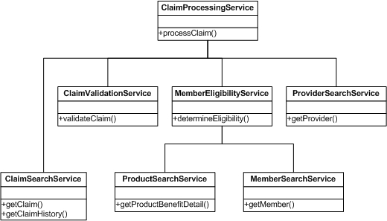
Figure 1 - Baseline Architecture

Caching Iteration

Architecture
The caching iteration uses the Spring Framework (see: Section 8.1) in order to implement a caching aspect that sits between the ProviderSearchService and/or MemberSearchService. The caching aspect acts as a type of interrupt. Whenever the ClaimsProcessingService requires information about a provider or a member, the call that is made is subsequently intercepted by the caching aspect. The aspect then has the opportunity to pull the provider or member information directly from memory instead of loading from the database. By doing this, Team Hooloovoo hopes to reduce the amount of time used to make calls out to the database in order to obtain information.

Figure 2 shows the caching architecture and, specifically, where the caching aspect fits into the system.
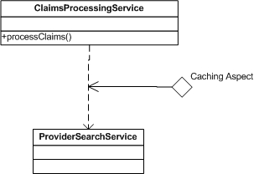
Figure 2 - Caching Architecture

Technical Decisions and Justifications

Static Caching vs. Dynamic Caching
Two types of caching were implemented within the caching iteration. The first, static caching, was used for provider information. In this case, all the possible providers were loaded into memory before claims processing even began. This was done because, after careful analysis, Team Hooloovoo decided that there were not enough total providers to cause a performance hit on the system by loading all the information into memory. Additionally, once the providers are loaded into memory, nothing else more needs to be done. Whenever the ClaimsProcessingService requires information about a provider, the information is pulled directly from memory with a hit rate of 100%.

Dynamic caching is a more flexible solution that has the advantage of scaling well with any amount of data. Dynamic caching only uses a subset of all the possible information, in this case member information, loaded at any given time. The decision was made to design a dynamic caching model after Team Hooloovoo realized that it would not be wise to load all the member information into memory – especially if many of the members are not accessed, or are only accessed once during claims processing.

Dynamic caching works by keeping the last X number of members in memory and flushing any members that exceed X. The idea behind this method is that, if a member has just been processed on one claim, that member will be processed again in the near future. This was determined from claims information provided by the project’s sponsor.

Threading Iteration

Architecture
Threading was difficult to implement due to the fact that the EJB specification prohibits the creation, destruction, or control of threads. In order to run each service simultaneously, we had to strip out all EJBs from the claim processing architecture.
After all EJBs were removed from the system, we were able to run each service as a thread. When a claim is received, the claims processing service creates threads for each of the services it requires. It then calls each of those services simultaneously. The member search service, in turn, calls two additional services simultaneously. Since all the services are processing simultaneously, the overall time to process a claim is reduced.
Once the EJBs were removed, threading was implemented as usual. Each service simply implemented the Runnable interface. Rather than the claims processing service calling methods such as getMember on the lower services, it simply created a new instance of the member service
thread and called the run method. The run method would, in turn, call the getMember method, and the service would return the same data it did in the baseline.

Figure 3 shows a basic layout of the threading architecture. Each service is running in its own thread.

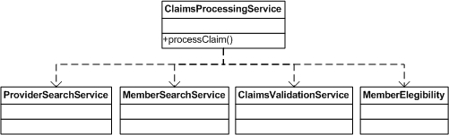
Figure 3 - Threading Architecture

Technical Decisions and Justifications

EJB Removal
As stated previously, threading is not possible with EJBs in place. This forced us to remove all EJBs from the baseline before threading was implemented. This proved to be quite a challenge and it violated Excellus's current service-oriented architecture.

Distributed Services Iteration

Architecture
The most difficult part of the distributed services iteration is determining how each computer will communicate so that each machine is doing as much work as it can with no backlog forming on any one machine.

In order to effectively provide communication between the various machines that would be part of the distributed services network, Team Hooloovoo has designed a system where one machine acts as the main communication point. This machine has two tasks. First, the machine, also known as the LoadBalancer, delegates claims to each of its buffers. Each buffer represents one physical machine within the distributed services architecture. However, the buffers reside on the communication machine (as opposed to each machine that is part of the distributed services architecture) in order to reduce network traffic between the buffers and the LoadBalancer.

Once the buffer has received a claim, the claim is sent across the network to a different, physical machine for actual processing. Each machine that is doing the processing contains a copy of the original baseline. While processing is going on, the LoadBalancer puts claims in the other LoadBuffers so they too may be sent for processing to the other physical machines.

When a claim has finished processing, the LoadBalancer is notified so that it can store the processed claim and put another onto the LoadBuffer. In the meantime, the distributed machines have already moved onto another claim.

The architecture for this process can be seen below in Figure 4Error: Reference source not found.

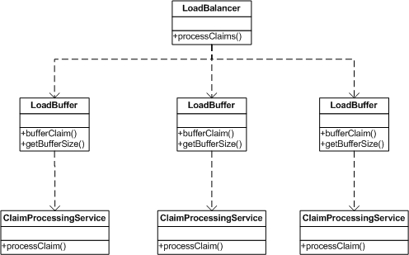
Figure 4 - Distributed Services Architecture

Technical Decisions and Justifications

Single LoadBalancer
The idea to use a single LoadBalancer was due to efficiency on the part of Team Hooloovoo rather than any necessary technical constraint. The team wanted to show that distributed services worked rather than spending time coding a robust solution. However, should Excellus decide to use distributed services, they could potentially have more than one machine act as the LoadBalancer so there is not one single point of failure in the system.

LoadBuffers on the Same Machine as LoadBalancer
Team Hooloovoo made the decision to put the LoadBuffers on the same machine as the LoadBalancer in order to reduce the traffic across the network. A lot of notifications and “talking” occur between the LoadBalancer and the LoadBuffers. If this communication occurred over the network, performance would be negatively affected. In addition, the distributed machines are busy processing the claims and the team did not want to take time to have these machines do anything more than process claims and notify the LoadBalancer that they were finished.

Project Issues

Underestimated Tasks

Baseline Devleopment
Initially, the project plan estimated that the lifecycle time for the baseline development would run approximately the same length of time as each iteration development. This estimation was based upon the fact that much of the baseline development was going to involve generated EJB code via the IBM WebSphere IDE. Additionally, due to the experience of two of Team Hooloovoo’s members and due to the architecture design given to us by Excellus, much of the requirements and design work was already completed for the baseline.

Unfortunately, the baseline development cycle took significantly longer than we expected at almost three weeks as opposed to the one week that had been initially planned. Issues arose with the EJB development.

Additionally, the team ran into issues during the testing portion of the baseline development cycle. It was more difficult to generate the data than the original estimate accounted for. This required that the team spend an extra few days implementing classes that could generate the XML data necessary for testing purposes. In the long run, this investment was worth it because it decreased the time spent in testing the other iterations. Also, the team needed to perform more investigation later in the testing process once they decided that the test data should proportionally match real Excellus data with respect to model object size and frequency of reoccurring data.

Learning Curve
The initial learning curve for the project was not too difficult because two members of Team Hooloovoo had enough experience with the claims service architecture that they could clear up any issues with the other two team members. However, when it came time to develop the three iterations, additional research needed to be performed into various technologies, including aspects and the Java Caching System (JCS) that was not accounted for in the project plan.

Overestimated Tasks

Design Development
Because the claims-oriented service architecture was already in place, very little was required from the team in the way of design. The only additional design that had to be performed was within the three iteration cycles. Even in these cases, because Team Hooloovoo attempted to keep the performance improvements modular, the iteration designs were separate from Excellus’ architecture. As a result, this kept the iteration designs relatively simple and the design portion of each iteration was much shorter than the three days that had been allotted in the project plan.

Caching Iteration
Initially, Team Hooloovoo ran into an issue within the caching iteration when the AspectJ solution suggested by Excellus’ sponsor did not work due to the fact that AspectJ would require a separate Java compiler. Because of this, the team would be unable to use the WebSphere platform which was a technical constraint set by Excellus. However, after discussing the problem with Eric Stephens, Team Hooloovoo went on to investigate aspect-oriented programming via the Spring Framework. The Spring Framework was much easier to integrate into the project and made it easy to integrate caching into the project.

Additionally, Team Hooloovoo discovered the Java Caching System (JCS), a part of the Apache Jakarta project. Between the combination of the two third-party technologies, the solution was extremely simple and elegant. As a result, despite the minor setback from AspectJ, Team Hooloovoo finished this iteration far ahead of schedule.

Distributed Services Iteration
The distributed services iteration turned out to be fairly straightforward due to the familiarity that Team Hooloovoo had with distributed systems based on previous classes and co-op experience. Because of this, the design of the distributed services iteration went smoothly and Team Hooloovoo came up with a design that was modular and relatively easy to implement. As a result, design and implementation were finished within five days as opposed to the thirteen days that were originally schedule for these three tasks.

Testing
As stated in section 3.5.1.1, testing took longer during the baseline development because the team had to generate the test data as well as make sure they were gathering proper metrics. Once these issues had been resolved, the testing became relatively automatic. Each of the following three iterations required very little time for metrics testing and gathering.

Metrics

Data

Caching – Static and Dynamic
Caching, by far, made the most performance improvement and, in addition, took the shortest amount of time to implement.

The implementation time for both static and dynamic caching took a total of fifteen man hours. However, this metric may not be entirely accurate for a couple reasons. Because caching was the first iteration the team was not as familiar with the baseline. As a result, team members required extra time to learn familiarize with the system. Additionally, aspect-oriented programming was a new technology that none of the team members had any experience with. This required extra research time which was counted within the man hours of the iteration. Because much of time was spent on research, the team calculated that only about five hours were actually spent on implementation.

Both static and dynamic caching gave improvements to the baseline. Because static caching caches all the data before the claims processing begins, access time for each piece of data is extremely short (within 25ms) for access. This is an incredible improvement over an access time of approximately 1750ms. Figure 5 shows the results for static caching vs. the baseline caching. One important note for this graph is that the pink line extends to 400 as the number of claims accessed at that short span of time.
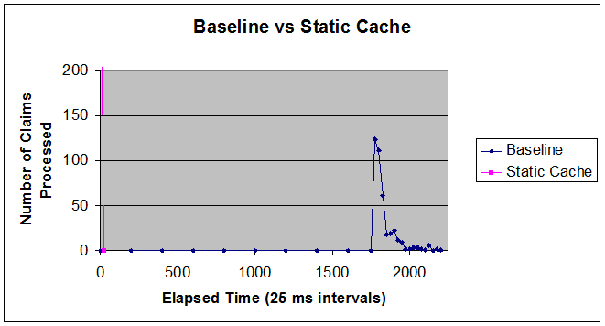
Figure 5 - Baseline vs. Static Cache Results

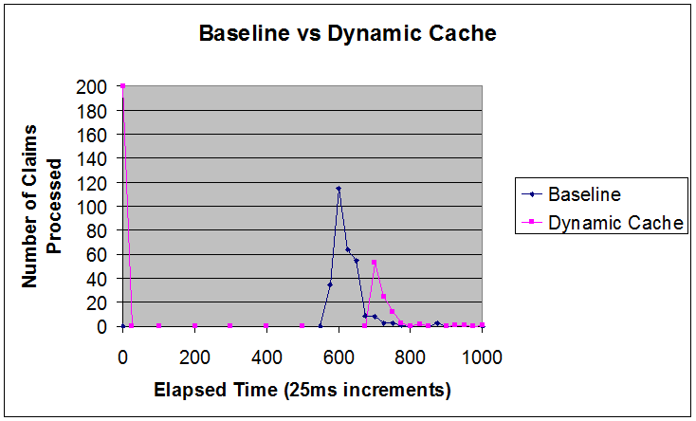
Figure 6 demonstrates the results for dynamic caching versus the baseline. In the case of dynamic caching, some information took longer to access than it took the baseline to access this item. This is because extra time was required to store the member data into memory. However, similar to what is seen in static caching, many of the claims (over half) are processed quickly. This more than makes up for the additional time needed to cache some of the data.
Figure 6 - Baseline vs. Dynamic Cache Results

Threading
The threading iteration took the longest to design and implement at 33 man hours. Additionally, major changes needed to be made to the architecture in order to get the threading iteration to work correctly.

Despite these two major issues, threading did provide improvement to the claims processing time. Compared to the baseline, threading made a 48.63% improvement to the amount of time it takes to process claims. This is shown by the first set of bars in Figure 7.

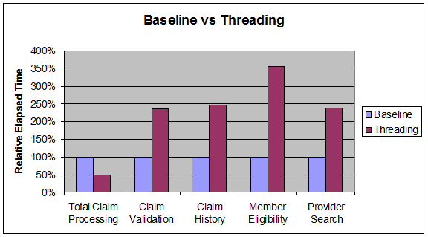
The other four bars in Figure 7 show the amount of time, relative to the baseline, that threading took to perform each part of the claims processing service. Each part of the process took anywhere from 236.20% longer (validation) compared to the baseline up to 354.66% longer (member). Because each of these processes were threaded, however, the overall improvement reduced the processing time by more than half. This information is shown in Figure 7 below.
Figure 7 - Baseline vs. Threading Results

Distributed Services
The top bar in Figure 8 shows the baseline processing time – 1034 seconds. The bottom bar shows the total time that distributed services took to run – 674 seconds. It should be noted that the distributed services bar is broken into two parts. The blue part was the actual processing time that distributed services takes to process one hundred claims. The second portion of the bar is the overhead that distributed services entails. This overhead (which was approximately 130 seconds) will exist on any distributed services solution. This is due to the fact that distributed services always requires setup time to begin buffering claims, send data across the network and perform various other tasks to make sure that claims are being distributed correctly.

Despite the fact that distributed services did not provide as much performance improvement as the other two iterations (roughly a 30% increase), this iteration took only 19 man hours to complete.
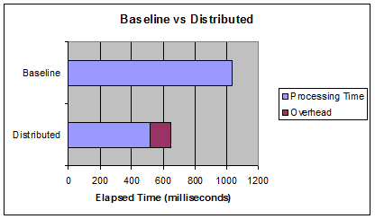
Figure 8: Baseline vs Distributed

Resource Usage
To measure CPU and memory usage, the baseline and all three iterations on the same computer with exactly the same applications running. CPU and memory usage was closely monitored before, during and at the end of the claims processing test using the Windows Task Manager.

The baseline and each iteration maximized the usage of the CPU. Because the computer will always attempt to execute claims processing requests as fast as possible, the CPU is always fully utilized. As a result, the CPU usage metric does not indicate any reliable form of performance data.

The following table shows the memory usage for the baseline and each iteration. The result from the caching iteration contradicts what one would normally expect. The team expected that the memory usage for the caching iteration would increase overall memory usage because large amounts of data would be placed in memory. However, memory usage decreased. The team suspects that this is due to the manner in which the services were loading the data. The services that return data, load that data from an XML file. When the service is loaded, that XML file needs to be loaded into memory and read. Since the data searching services are invoked less frequently in the caching iteration, the file is loaded less often. The team believes that this is the reason for the lower memory usage.

Not surprising is the fact that the threaded iteration used more memory than the baseline. This is most likely due to the fact that the memory associated with each thread must constantly be swapped in and out of memory as it is activated and suspended.

Only the memory usage of the computer running the Load Balancer was recorded for the distributed iteration. It is assumed that the computers running the service will use memory similarly to the baseline. Because the load balancer is not processing any claims, the memory usage is significantly lower.
Iteration | Memory Usage
Baseline | 93 MB
Caching | 58.5 MB
Threaded | 526.9 MB
Distributed (Load Balancer) | 37 MB

Function Points
As a measurement of effort, the team decided to use function points. It was decided that function points would be a more accurate representation of effort than lines of code. In order to maintain consistency and make a meaningful measurement, the team decided what specifically would be considered a function point for our project. For each iteration, the team determined the number of new and modified classes and interfaces, the number of new and modified methods, and the number of new and modified configuration files.

Interestingly, the effort indicated by function points was very similar to the number of man-hours involved in each iteration. For both measurements, caching involved the least effort. The distributed iteration required only slightly more effort than caching. The threaded iteration required the most effort as indicated by both measurements. Having two separate metrics that indicate the same overall results helps to reinforce each other. This has given the team even more confidence in the recommendations that were made.

Summary of Results
Figure 9 shows how the iterations compare to each other. The red bars represent the percent performance improvement that the iterations provided while the blue line shows the number of man hours required to implement that performance improvement. From this graph, caching is, by far, the best performance improvement.

Figure 10 represents the amount of performance improvement relative to the amount of man hours. Again, caching is the best improvement. Using these statistics, distributed services is second and threading is third.
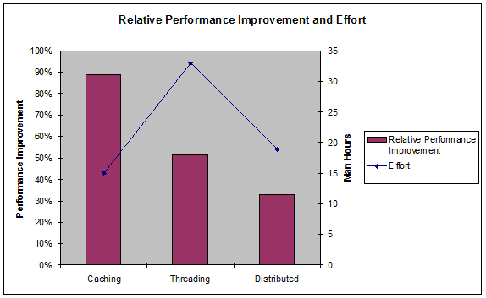
Figure 9 - Relative Performance Improvement and Effort

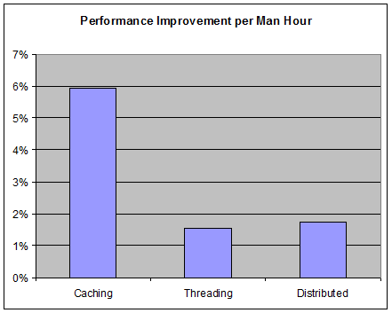
Figure 10 - Performance Improvement per Man Hour

Project Assessment

Technical Reflections
This project had major technical advantages. The first was that this project was extremely well-defined. As a result, very little work was needed to flush out the requirements or to clarify any aspects of the project before the team could begin work. Additionally, Excellus’ contact point, Eric Stephens, had a very solid technical background at the company and was not only able to provide any information that our team needed, but was also able to provide suggestions and ideas that Team Hooloovoo could research or attempt. This helped at various points (during the caching iteration, for example) when the team was stuck due to technological limitations.

After the baseline prototype had been developed, the project became very easy to manage due to Team Hooloovoo developing modular performance improvements. This was done for two reasons. First, the team wanted any performance improvement to easily be added or removed from the project. This gives Excellus the flexibility to decide which improvements to include and which ones to remove. Additionally, the performance improvements were designed this way to give Team Hooloovoo greater control over metrics gathering. In both cases, it is relatively easy for a performance improvement to be added or removed as necessary. Only minor additional work should be needed in order to integrate multiple enhancements.

The most difficult technical challenge within this project was the research aspect. Because all the team members were using new technologies to make improvements (specifically caching and distributed services), research had to be performed first in order to prevent the project from moving forward into a technology only to have a setback because the technology was not understood enough. This problem occurred during the caching iteration, but this was mitigated within the other two iterations.

Team Assessment
Team Hooloovoo worked very well together on this project. Because the team members are friends and have worked together on various other projects (both in and out of the classroom), the team as a whole knew and understood the strengths and weaknesses of each member of the team. This allowed the team to divide up the workload and the responsibilities quickly and efficiently according to where each member would be responsible for aspects of the project that he would be most interested in and familiar with. As a result, this allowed the team to begin work without much difficulty. Additionally, each member concentrated on an area of the project where his knowledge base was most useful.

The other strong aspect of Team Hooloovoo was the constant communication that went on between team members. Early on in the project, the team made sure that each member was constantly updating and informing the other members of what he was working on. By doing this, it prevented work from being duplicated when it was not necessary. Additionally, Team Hooloovoo met at least once a week (and usually more) for a working session in which each member would have a portion of the project to work on and would receive help from the other members as needed.

Finally, the knowledge base of two of the team members helped this project immensely. Having a solid understanding of Excellus’ claims-service architecture allowed the team to quickly learn the many intricacies of the architecture with minimal learning time.

Team Hooloovoo did not see any major setbacks in this project (other than what is discussed in section 3.5). The stress of other classes did take a toll on the team, especially at the end of the winter and spring quarters. However, Team Hooloovoo mitigated this by having a few nights off every so often so that they could relax and be rejuvenated for the next working session.

Sponsor Assessment
Eric Stephens, the main contact point for Excellus BCBS, provided positive feedback to our group at the end of the project. He felt that we did an excellent job of solving his biggest concern from the first half of the project which was the fact that we did not communicate with him frequently enough. This was mitigated by having bi-weekly meetings with Eric in order to update him with the project status, ask him any technical questions about Excellus’ systems or just to receive general feedback. Additionally, Eric felt that when he did meet and interact with the group, information was communicated effectively. Enough information was provided so Eric could remain up-to-date, but, at the same time, Team Hooloovoo did not provide technical details that Eric was not interested in. Last of all, Eric liked that the team researched technical problems and put a lot of thought into them before coming to him to discuss what route would be the best for the project.

Eric also appreciated that the team explored all the necessary performance improvements even though the caching iteration was so huge of an improvement that the project could have potentially stopped at that point.

Overall, the feedback from Eric was positive and he appreciated having a team that took the project seriously and accomplished everything it set out to do.

Recommendations
This section represents the final recommendations that Team Hooloovoo is making to Excellus BCBS with respect to the performance enhancements investigated for the claims service-oriented architecture performance prototype. These recommendations are based upon the work performed by Team Hooloovoo and the metrics that were gathered by the team (see sections 2.3 and 4).

Caching Iteration Recommendation
Caching was the easiest of the iterations to implement. Additionally, caching also provided the greatest performance increase of all three iterations. Because of this, Team Hooloovoo highly recommends that Excellus implements caching in each service. Both dynamic and static caching have benefits. Static caching should be used where the hardware, especially memory, is available to cache all the data that will be needed. Dynamic caching should be used where there is not enough memory to store all the necessary data, or it does not make sense to load all the data into memory.

One important note is that, in order for caching to be effective, it is necessary that the same data is accessed repeatedly. Because of this, Excellus should investigate where repeated data access occurs most on their systems. These locations would benefit the most from the caching improvement.

Threading Iteration Recommendation
Threading was the hardest of the iterations to implement. The EJB specification strictly prohibits threading inside an EJB, so all EJBs had to be removed before the team could even begin to implement threading. This is currently a problem within Excellus’ architecture because they use EJBs extensively. In addition, threading does not increase performance on machines that do not have dual-core processors. To purchase these machines could be expensive. Last of all, threading took the longest of the iterations to implement.

For these reasons, the team does not recommend that Excellus implements threading in future services.

Distributed Services Iteration Recommendation
The distributed services iteration provided moderate performance improvements with little effort. Because of this, Team Hooloovoo recommends that Excellus considers the use of distributed services to speed up claims processing. However, in order for distributed services to be effective, Excellus will need additional machines on which claims processing can be performed. These machines don’t need to be exceptionally powerful, but there will need to be many of them in order to be effective.

A major advantage of distributed services is the fact that there is redundancy within the system. If one of the distributed machines fails at any point, the other machines will continue to run and will be able to complete the claims that the failed machine was unable to complete.

Because of these reasons, the distributed services technique is recommended by Team Hooloovoo.

Conclusion

Accomplishments
Team Hooloovoo accomplished everything that they set out to do within the scope of this Senior Project. The team implemented the baseline architecture which is a representation of Excellus’ current claims architecture. Team Hooloovoo also developed all three iterations: caching, threading and distributed services and analyzed these iterations which resulted in this final report.

Final Deliverables
The final deliverables made by Team Hooloovoo to Excellus BlueCross BlueShield as specified by the SRS include the following:

- This Final Report and the recommendation contained within this report (section 6)
- The final version of all project documentation
- All source code including baseline, caching, threading and distributed services

Additional Technologies

Spring Framework
The Spring Framework provides the necessary application framework for Java/J2EE that allowed Team Hooloovoo to use aspect oriented programming within the caching iteration as well as using it to capture data necessary for metrics gathering.

Web Site URL: http://www.springframework.org/

Java Caching System
The Java Caching System (JCS) is a product of the Apache Jakarta project and is “intended to speed up applications by providing a means to manage cached data of various dynamic natures” (Apache Software Foundation, 2006). The JCS allowed Team Hooloovoo to quickly and easily cache claims data without having to implement their own system. This cut down on development time enormously during the caching iteration.

Web Site URL: http://jakarta.apache.org/jcs/index.html

Bibliography
"About Us." Excellus BlueCross BlueShield. Excellus BlueCross BlueShield. 26 April 2006
<https://www.excellusbcbs.com/about_us/our_company/index.shtml>.

Apache Software Foundation, (2006). JCS - Java caching system. Retrieved May 5, 2006, from The
Apache Jakarta Project Web site: http://jakarta.apache.org/jcs/index.html

